

COURSE DESIGN REPORT

STUDNET NO： 9200214024
STUDNET NAME： Abdullah Alshakaa
CLASS： 212

Chapter 1: REQUIEMENTS OF COURSE PROJECT
1.1Introduction
This report documents the design and implementation of an Income/Expense Management System is a full-stack web application that allows users to categorize and analyze their personal financial transactions. The system is built using React.js, Node.js with Express.js, and PostgreSQL with Prisma ORM, following a strict Model-View-Controller architecture with a role-based access control which is a user and admin and provide some AI financial assistant powered by Google Gemini Flash. In The following chapters discuss the project requirements, the system and database design, and the final implementation results.
1.2 Problem Description
The reason why this project was choosing because In daily life people often struggle to keep a clear picture of their spending and incomes habits the reason way lack of organized tracking system and Without structured financial records, also these system make it hard to user to identify spending patterns, plan budgets effectively, or make informed purchasing decisions.
This program addresses these challenges or issues by delivering a platform where users can record every financial transaction and categorize it based on the type and quantity and immediately view analytics summarizing their financial history. The system take step farther by implementing an AI-powered advisory layer powered by Google Gemini Flash, which can generate personalized budget plans, assess purchase affordability, and answer free-form financial questions using the user's own transaction history as context.
The system follows the Model-View-Controller (MVC) architectural pattern with strict separation of concerns across three explicit layers: the View layer (React.js frontend), the Controller layer (Express.js route handlers), and the Service/Model layers (business logic and database access). The database is managed through PostgreSQL with Prisma ORM, ensuring data integrity, type safety, and index-optimized query performance.
1.3 Functional Requirements
The system is required to implement the following functional capabilities:
Core Transaction Management
The primary g requirements for this project are the four CRUD operations on financial records:
- Add Record: The system must allow users to create a complete financial record. Each record requires a user-defined unique Record ID, a transaction type (income or expense), an amount stored as a decimal value, a category, a transaction date, and optional name of the operator who is responsible for the transaction. Notes are optional. The backend must perform a duplicate ID check before inserting any record if the submitted Record ID already exists in the system even if the record was previously soft deleted
- Edit Record: The system must allow users to modify any field of an existing record with one critical field which is Record ID is permanently fixed can not be changed after creation. The edit interface must visually read only disabling the ID field and a "Fixed" indicator. The backend service layer strips the ID from any update payload before processing, enforcing this constraint at both the presentation and business logic layers.
- Delete Record: The system must allow users to delete specific records directly from the list view. Deletion is performed as a soft delete the record is hidden from the user's view but preserved in the database with a deleted_at timestamp. This design ensures audit trail integrity and allows administrator restoration of mistakenly deleted records.
- Search and Filter with Server-Side Pagination: The system must support querying records by Record ID , transaction type, and category All filtering must be processed server-side the database executes the query with the applied filters, and only the matching subset of records is returned to the client. Results are paginated with a configurable page size, and the pagination totals reflect the filtered count rather than the total record count.
Authentication and Security
The system implements a two-token authentication mechanism. A short-lived JWT access token (15-minute expiry) is stored exclusively in React application state and is never written to localStorage, preventing XSS-based token theft. A long-lived refresh token (7-day expiry) is delivered via an httpOnly cookie, preventing JavaScript access. Refresh tokens are stored in the database as bcrypt hashes. On every page load, the frontend silently attempts to exchange the refresh cookie for a new access token, restoring sessions without requiring the user to log in again.
Role-Based Access Control
The system defines two user roles: USER and ADMIN. The USER role can access to the user's own records, dashboard analytics, AI features, and category management. The ADMIN role additionally could access to audit views of all users' records, user account management, system-wide analytics, and system category administration. All admin-only routes are protected by a role-verification middleware layer that runs after token verification.
Analytics Dashboard
The system provides a financial analytics dashboard displaying total income, total expense, and net balance for the selected month also some visual an income vs expense trend chart across the last six months; a spending breakdown by category chart and a list of the five most recent transactions including summary information about these records. All analytics data is aggregated server-side using database GROUP BY and SUM operations, ensuring accuracy regardless of the number of records.
Category Management
The system provides 13 built-in system categories visible to all users, managed only by admins. Users also can additionally create personal categories that are visible only to the user who creates the category. Both system and personal categories support a name, an emoji icon, and a hex color code used consistently across record badges, chart slices, and category cards.
AI-Powered Features
Three AI features are powered by Google Gemini Flash 2.5:
- Budget Planner: Users provide a wanted budget the system analyzes the user's past spending patterns and generates a recommended monthly budget allocation per category. The user could adjust the AI's suggestions before saving them as persistent budget goals.
- Purchase Advisor: Evaluates whether a planned purchase is affordable given the user's current monthly surplus and saved budget goals. Returns a structured verdict of "can afford," "wait," or "adjust spending."
- Finance Chat: A conversational interface where users ask any financial question. The AI receives the user's full financial context (aggregated summaries, not raw records) as part of every prompt.
AI responses are cached in the database using SHA-256-keyed entries to avoid redundant API calls. Users have a configurable daily request limit (10 for USER, 50 for ADMIN), and cache hits do not count toward this limit.
1.3 Non-Functional Requirements
Requirement | Specification
Security | bcrypt password hashing (saltRounds = 12), httpOnly cookies for refresh tokens, HTML input sanitization, rate limiting on authentication endpoints
Data Integrity | Soft delete preserves financial records; duplicate ID check prevents data corruption; decimal.js arithmetic prevents floating-point errors on all currency calculations
Performance | Database indexes on all frequently queried columns (type, category, date, deleted_at); server-side pagination limits response payload size
Maintainability | Strict MVC separation with ARCHITECTURE GUARD comments preventing PrismaClient imports in service files; snake_case naming convention applied across the entire codebase
Usability | Responsive Tailwind CSS layout; toast notifications for all user actions; loading skeleton placeholders prevent layout shift
1.4 Use Case Analysis
The system defines two primary actors:
- User: A registered account holder who manages their own financial records, views their personal analytics, uses the AI assistant, and manages their personal categories. All actions require the user to be authenticated via the login portal.
- Admin: An elevated-privilege account that inherits all User capabilities and additionally manages user accounts, audits records across the entire platform, manages system-wide categories, and views platform-level analytics and AI usage statistics. Admin accounts are promoted from User accounts by an existing Admin through the administration panel.
The following use case diagram illustrates the system boundary, actors, and the relationships between them:
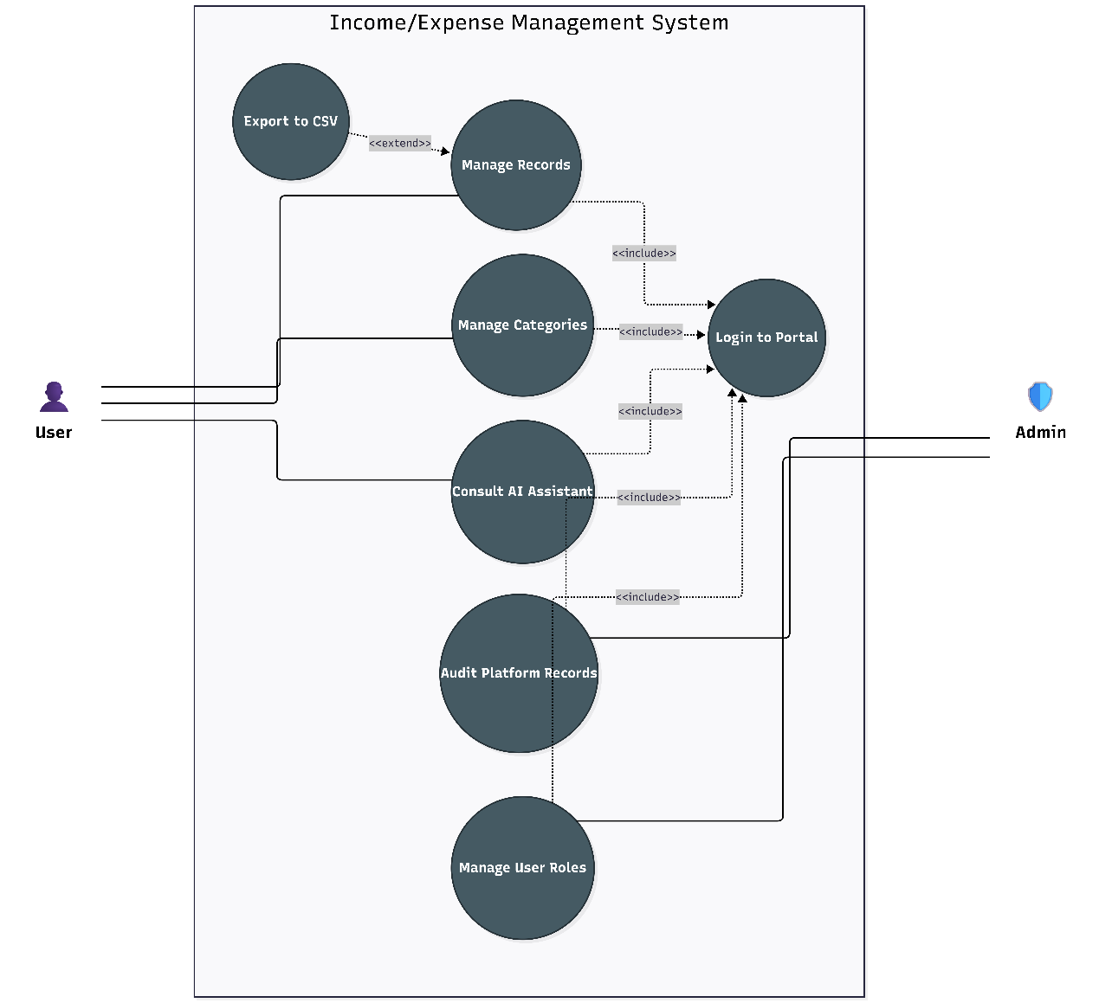
Figure 1.1Use Case Diagram
Use Case Descriptions:
UC-01: Manage Records The User creates, edits, deletes and searches financial records. This use case meets all four teacher-specified requirements. The Record ID uniqueness check and the read-only ID constraint on edit are enforced at both the frontend (disabled field) and backend (service-layer validation) levels. Export to CSV extends this use case, providing a filtered data export without navigating away from the records view.
UC-02: Manage Categories The User creates personal categories and sets optional monthly spending limits per category. The Admin additionally manages system categories that are shared across all user accounts. Deactivation (not hard deletion) is used for system categories to preserve the referential integrity of existing records.
UC-03: Consult AI Assistant The User interacts with three AI-powered tools: the Budget Planner, Purchase Advisor, and Finance Chat. The AI service constructs a financial context summary from the user's analytics data before every Gemini API call, ensuring responses are grounded in actual transaction history rather than generic advice.
UC-04: Audit Platform Records (Admin only) The Admin views all records for any selected user, including soft-deleted entries. The Admin may restore a soft-deleted record or permanently remove it after a typed confirmation. This use case is the primary demonstration of the soft-delete system's value.
UC-05: Manage User Roles (Admin only) The Admin promotes users to the ADMIN role or demotes them back to USER. A safety constraint prevents any admin from modifying their own role. The first admin account is established through the database seed file; all subsequent promotions occur through this use case.

Chapter 2: DESIGN OF COURSE PROJECT
2.1 System Architecture Overview
The system design to a strict Model-View-Controller (MVC) architectural pattern implemented across two separate processes a React.js frontend (client) and a Node.js/Express.js backend (server). The two communicate exclusively through a REST ful HTTP API, ensuring complete separation between the presentation layer and the business logic layer.
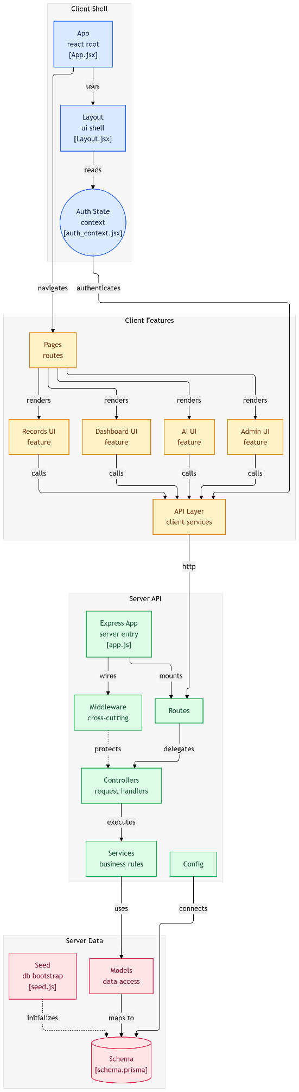
Figure 2.1System Architecture Diagram
The architecture is divided into three named layers:
View Layer (React Frontend): All user interface components, page routing, and application state management reside in the client. The View layer never contains business logic or direct database access. HTTP communication is handled by a Axios instance which is configured with request interceptors for JWT attachment and response interceptors for the silent token refresh on 401.
Controller Layer (Express.js): Route handlers receive HTTP requests, invoke exactly one service function, and return the response. Controllers are kept thin each handler is limited to 15 lines of code to make sure that the MVC structure is consistent No validation, no business logic, and no direct database calls appear in this layer.
Service and Model Layers (Business Logic and Data Access): All input validation, duplicate checks, business rules, and calculations reside in service modules. while the Service functions call only model functions they never import the Prisma client directly. Model modules contain all the Prisma ORM queries and return raw database objects.
The following diagram illustrates the complete request lifecycle, showing how a request flows from the React frontend through the middleware chain, controller, service, and model layers to PostgreSQL:
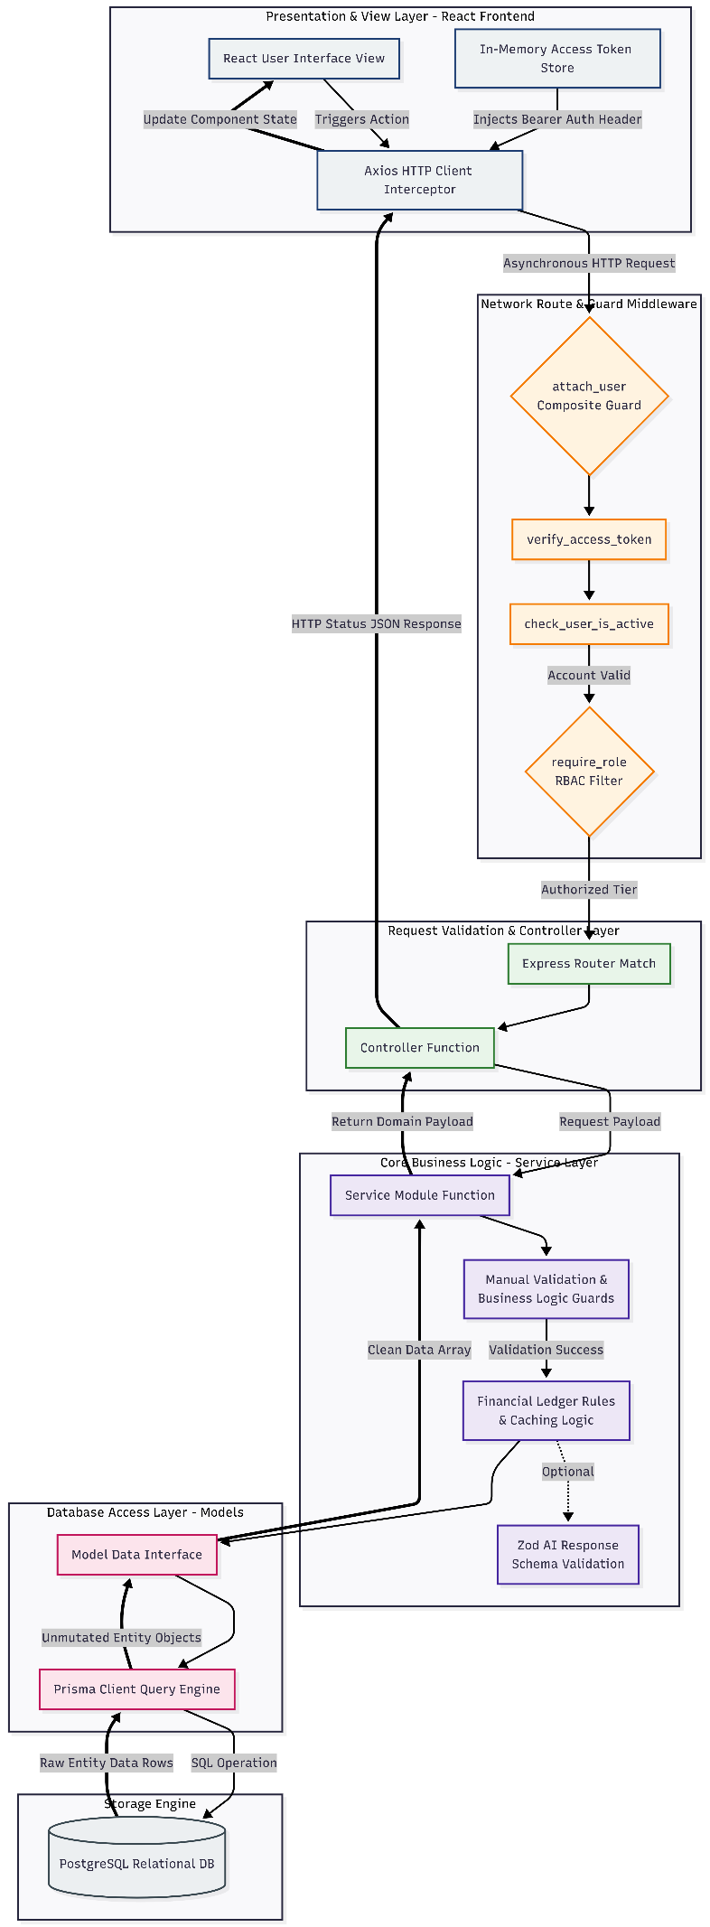
Figure 2.2MVC Request Lifecycle

2.2 Database Design
In this program the 7 table was built for handle all the data flow for the program
2.2.1 Entity-Relationship Diagram
The database consists of seven entities. The following ER diagram shows the complete relationship structure:
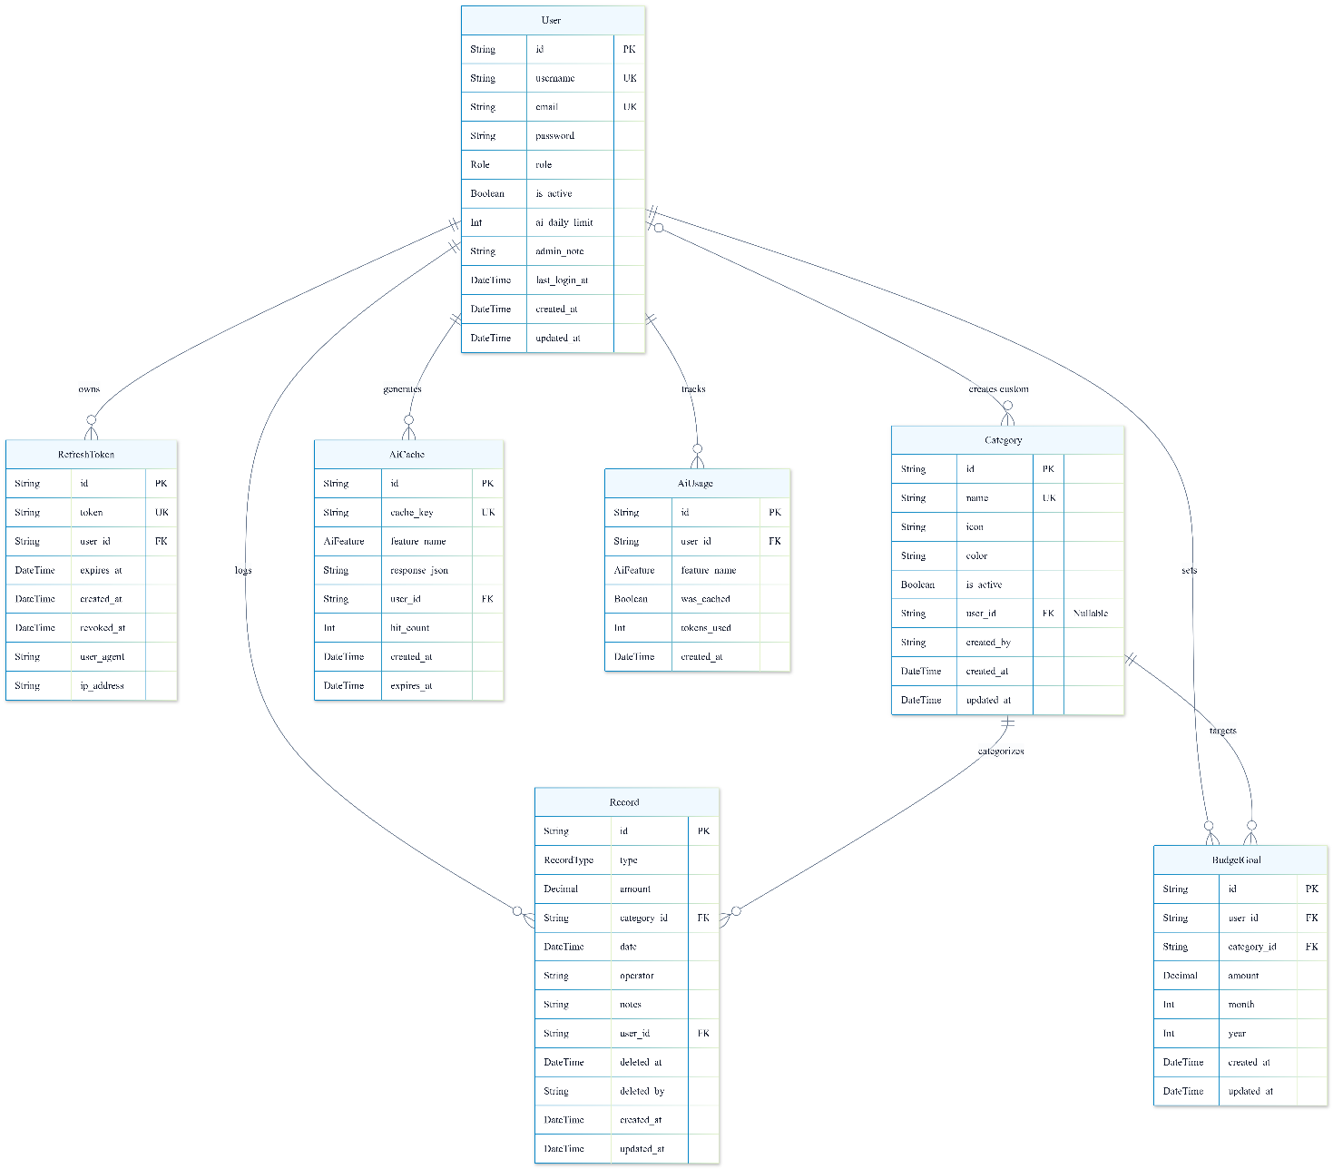
Figure 2.3 ER Diagram

Relationship Summary:
- One User has relation for all the following tables many Records, RefreshTokens, AiCache ,AiUsage and BudgetGoals.
- One Category has many Records and many BudgetGoals.
- Each Record belongs to exactly one User and exactly one Category.
- Each BudgetGoal belongs to exactly one User and exactly one Category, with a unique constraint enforcing that only one goal per category per month per user can exist.
- RefreshToken is cascade-deleted when the parent User is deleted. All other entities use RESTRICT to prevent orphaned financial records.
2.2.2 Table Structure and Field Definitions
Table 1: User
Stores registered user accounts. Passwords are stored exclusively as bcrypt hashes. The ai_daily_limit field allows per-account AI quota overrides by an admin.
Field | Type | Constraints | Description
Id | TEXT | PRIMARY KEY | cuid() generated unique identifier
Username | TEXT | UNIQUE, NOT NULL | Display name, minimum 3 characters
Email | TEXT | UNIQUE, NOT NULL | Login identifier, must be valid email format
Password | TEXT | NOT NULL | bcrypt hash only — never plain text
Role | Role ENUM | NOT NULL, DEFAULT 'USER' | USER or ADMIN
is_active | BOOLEAN | NOT NULL, DEFAULT true | False = account deactivated, login refused
ai_daily_limit | INTEGER | NOT NULL, DEFAULT 10 | Maximum non-cached AI requests per day
admin_note | TEXT | NULLABLE | Internal admin annotation
last_login_at | TIMESTAMP | NULLABLE | Updated on every successful login
created_at | TIMESTAMP | NOT NULL, DEFAULT NOW() | Account creation timestamp
updated_at | TIMESTAMP | NOT NULL | Auto-updated on any change
Indexes: email (for login lookup), role (for admin filtering)

Table 2: RefreshToken
Stores long-lived session tokens. The token column holds a bcrypt hash of the actual cookie value the raw token is never persisted. One user can have multiple active rows representing simultaneous sessions on different devices.
Field | Type | Constraints | Description
Id | TEXT | PRIMARY KEY | cuid() generated
Token | TEXT | UNIQUE, NOT NULL | bcrypt hash of the refresh JWT
user_id | TEXT | FK → User(id) ON DELETE CASCADE | Token owner
expires_at | TIMESTAMP | NOT NULL | Token expiry (7 days from creation)
created_at | TIMESTAMP | NOT NULL, DEFAULT NOW() | Session creation time
revoked_at | TIMESTAMP | NULLABLE | Null = active; timestamp = logged out
user_agent | TEXT | NULLABLE | Browser or device string
ip_address | TEXT | NULLABLE | Client IP at time of login
Indexes: user_id, expires_at (for cleanup queries)

Table 3: Category
Stores both system and user-personal categories. The user_id field is the discriminator: NULL means the category is a system category visible to all users; a non-null value means it is a personal category visible only to that user.
Field | Type | Constraints | Description
Id | TEXT | PRIMARY KEY | cuid() generated
Name | TEXT | UNIQUE, NOT NULL | Display name (2–30 characters)
Icon | TEXT | NOT NULL, DEFAULT '📁' | Single emoji character
Color | TEXT | NOT NULL, DEFAULT '#6B7280' | Hex color code for badges and charts
is_active | BOOLEAN | NOT NULL, DEFAULT true | False = hidden from record form dropdown
user_id | TEXT | FK → User(id), NULLABLE | Null = system; non-null = personal
created_by | TEXT | NOT NULL | user_id of creator (admin or user)
created_at | TIMESTAMP | NOT NULL, DEFAULT NOW() | Creation timestamp
updated_at | TIMESTAMP | NOT NULL | Auto-updated on change
Indexes: name, is_active, user_id

Table 4: Record
The core financial data table. The id field is a user-defined string primary key allows users to assign meaningful identifiers (e.g. "REC-001"). The amount field uses DECIMAL(15,2) to store exact monetary values without floating-point errors. Soft deletion is implemented through deleted_at and deleted_by fields rather than physical row removal.
Field | Type | Constraints | Description
Id | TEXT | PRIMARY KEY | User-defined unique string (e.g. "REC-001")
Type | RecordType ENUM | NOT NULL | 'income' or 'expense' — DB-enforced
Amount | DECIMAL(15,2) | NOT NULL | Exact currency value, no floating-point
category_id | TEXT | FK → Category(id) ON DELETE RESTRICT | Record category
Date | DATE | NOT NULL | Transaction date (no time component)
Operator | TEXT | NOT NULL | Person who performed the transaction
Notes | TEXT | NULLABLE | Optional free-text notes
user_id | TEXT | FK → User(id) ON DELETE RESTRICT | Record owner — included in every query
deleted_at | TIMESTAMP | NULLABLE | Null = active; timestamp = soft-deleted
deleted_by | TEXT | NULLABLE | user_id of who performed soft deletion
created_at | TIMESTAMP | NOT NULL, DEFAULT NOW() | Row creation time
updated_at | TIMESTAMP | NOT NULL | Auto-updated on change
Indexes: user_id, type, category_id, date, deleted_at, compound (user_id, deleted_at)

Table 5: AiCache
Stores Gemini API responses keyed by a SHA-256 hash of the request inputs. When a cache hit is found with expires_at in the future, the stored response is returned immediately without an API call. Cache entries expire according to feature-specific (24 hours for budget plans, 12 hours for purchase advice, 1 hour for chat analysis).
Field | Type | Constraints | Description
id | TEXT | PRIMARY KEY | cuid() generated
cache_key | TEXT | UNIQUE, NOT NULL | SHA-256 hash of user_id + feature + inputs
feature_name | AiFeature ENUM | NOT NULL | plan_expenses, advise_purchase, or analyze_finances
response_json | TEXT | NOT NULL | Complete Gemini response as JSON string
user_id | TEXT | FK → User(id) | User who generated this cache entry
hit_count | INTEGER | NOT NULL, DEFAULT 0 | Incremented each time this entry is served
created_at | TIMESTAMP | NOT NULL, DEFAULT NOW() | Entry creation time
expires_at | TIMESTAMP | NOT NULL | After this time, the entry is considered stale
Indexes: cache_key, expires_at, user_id

Table 6: AiUsage
Logs every AI request made by every user, whether served from cache or from a live Gemini API call. This table serves two purposes: records the daily request limits (counting rows where was_cached = false for today) and providing the admin with a usage report across all users.
Field | Type | Constraints | Description
id | TEXT | PRIMARY KEY | cuid() generated
user_id | TEXT | FK → User(id) | Requesting user
feature_name | AiFeature ENUM | NOT NULL | Which AI feature was invoked
was_cached | BOOLEAN | NOT NULL, DEFAULT false | True = no API cost, does not count toward limit
tokens_used | INTEGER | NULLABLE | Token count from Gemini response metadata
created_at | TIMESTAMP | NOT NULL, DEFAULT NOW() | Request timestamp
Indexes: user_id, created_at, compound (user_id, created_at) for daily limit queries, was_cached

Table 7: BudgetGoal
Stores the user's monthly spending targets per category, created either manually or by saving an AI-generated budget plan. A unique constraint ensures only one goal per user per category per month/year combination can exist. The backend uses an upsert operation when saving, so re-running the AI planner for the same month replaces the existing goals cleanly.
Field | Type | Constraints | Description
Id | TEXT | PRIMARY KEY | cuid() generated
user_id | TEXT | FK → User(id) | Goal owner
category_id | TEXT | FK → Category(id) ON DELETE RESTRICT | Target category
amount | DECIMAL(15,2) | NOT NULL | Planned spending limit for the month
month | INTEGER | NOT NULL | Month number (1–12)
year | INTEGER | NOT NULL | Calendar year
created_at | TIMESTAMP | NOT NULL, DEFAULT NOW() | Goal creation time
updated_at | TIMESTAMP | NOT NULL | Auto-updated on change
Unique constraint: (user_id, category_id, month, year) — one goal per category per period Indexes: user_id, compound (user_id, month, year)

2.3 Functional Design
This section describes the primary functional modules of the system, organized by feature area. Each module is implemented as a triplet of Controller, Service, and Model files following the MVC pattern.
2.3.1 Authentication Module
The authentication module manages user registration, login, session maintenance, and password management. It implements a two-token security model combining short-lived JWT access tokens with long-lived refresh tokens stored as bcrypt hashes.
Function | Layer | Description
register_user | Service | Validates username (min 3 chars), email format, password strength (min 8 chars); checks for duplicate email; hashes password with bcrypt (saltRounds=12); creates User record with default USER role
login_user | Service | Retrieves user by email (includes password hash); compares with bcrypt.compare; verifies is_active = true; signs 15-minute access JWT; signs 7-day refresh JWT; stores hashed refresh token in RefreshToken table; updates last_login_at
refresh_access_token | Service | Decodes refresh JWT from httpOnly cookie to extract user_id; hashes the raw token and queries RefreshToken table for a matching, non-revoked, non-expired row; verifies user is still active; issues new access token
logout_user | Service | Sets revoked_at on the RefreshToken row; the httpOnly cookie is cleared by the controller response
change_password | Service | Fetches user with password hash; verifies current password with bcrypt.compare; validates new password minimum length; hashes new password; persists via user_model.update_password
The middleware chain applied to all protected routes is: verify_access_token → check_user_is_active → attach_user. For admin-only routes, require_role(['ADMIN']) is appended.
2.3.2 Record Management Module
The record management module implements all four CRUD requirements. All record queries include mandatory filters for user_id (ownership check) and deleted_at: null (soft-delete filter) to ensure users can only access their own active records.
Function | Layer | Description
create_record | Service | Validates all mandatory fields; validates type enum; validates amount is positive Decimal; checks category exists and is active; calls find_by_id_any (no soft-delete filter) to detect duplicate IDs including previously deleted records; inserts record
get_records | Service | Parses page/limit from query params; builds filter object from record_id, type, category_id, date_from, date_to parameters; calls find_many with user_id + deleted_at:null mandatory filters; returns paginated response
update_record | Service | Strips id field from incoming data before any processing; validates updated fields; confirms ownership via find_by_id (which includes user_id + deleted_at:null filters); calls record_model.update
delete_record | Service | Confirms ownership; calls soft_delete which sets deleted_at = NOW() and deleted_by = user_id; record is hidden from all user queries but preserved in database
generate_record_id | Service | Counts today's records for the user; constructs REC-YYYYMMDD-NNNN format; verifies uniqueness with find_by_id_any; returns suggestion to frontend for pre-filling the add form
export_records | Service | Fetches all matching records without pagination using current active filters; serializes amounts as fixed-decimal strings; streams as CSV using csv-stringify library
restore_record | Service (Admin) | Resets deleted_at and deleted_by to null; no user_id ownership filter — admin can restore any record
hard_delete_record | Service (Admin) | Permanently removes the database row; only reachable after the user types "DELETE" in the frontend confirmation dialog
2.3.3 Analytics Module
The analytics module aggregates transaction data using PostgreSQL GROUP BY and SUM operations. All aggregations apply the mandatory deleted_at: null filter so soft-deleted records are excluded from all totals.
Function | Layer | Description
get_summary | Service | Aggregates total income and total expense for a given month/year or date range; calculates net_balance using decimal.js subtraction to avoid IEEE 754 floating-point errors
get_monthly_trends | Service | Fetches records for the past N months; groups by month label; fills in zero values for months with no records (prevents chart gaps); returns array suitable for line chart rendering
get_category_breakdown | Service | Groups expenses by category_id; batch-fetches category names, icons, and colors; calculates percentage of grand total per category using decimal.js division; returns sorted array for pie chart
get_daily_balance | Service | Fetches records in a date range ordered by date; accumulates a running balance using decimal.js; fetches prior balance from before the range start so the chart reflects true historical wealth
get_system_summary | Service (Admin) | Same aggregation as get_summary but with no user_id filter — returns platform-wide totals across all users
2.3.4 AI Features Module
The AI module implements a cache-first pattern for all three Gemini-powered features. Before every API call, the module computes a SHA-256 cache key from the request inputs and checks the AiCache table. Before every non-cached API call, the module counts today's non-cached requests against the user's daily limit. The following flowchart illustrates this logic in full detail:
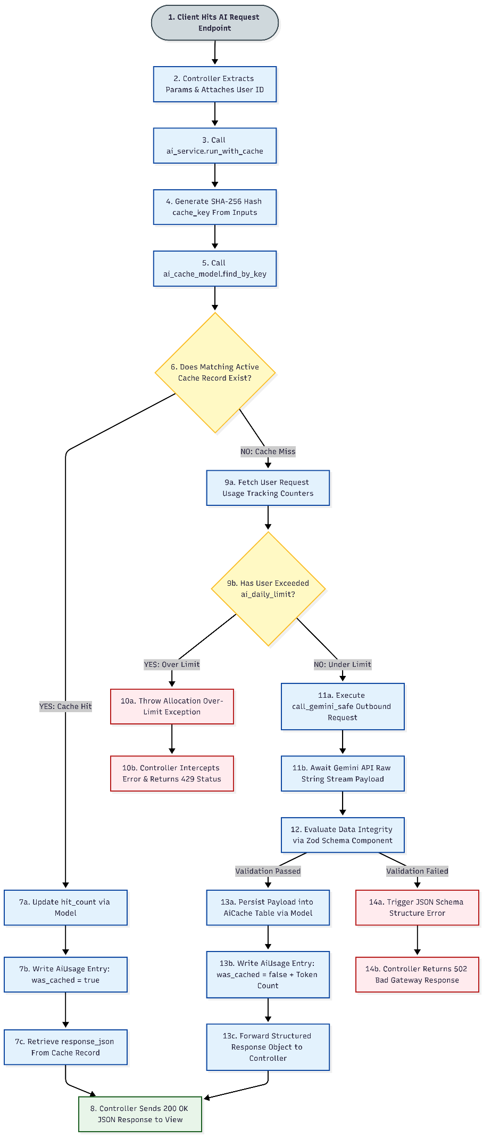
Figure 2.4 AI Cache Flowchart
Function | Layer | Description
build_financial_context | Service | Calls analytics_service.get_summary, get_category_breakdown, and get_monthly_trends; calls budget_goal_service.get_monthly_goals; assembles a structured JSON summary (~200 tokens) rather than sending raw records (~2000+ tokens)
plan_expenses | Service | Cache key: SHA-256(user_id + "plan" + target_budget + month + year); injects financial context and budget goals into Gemini prompt; returns editable category allocation array validated with Zod schema
advise_purchase | Service | Cache key: SHA-256(user_id + "advise" + item_name + item_cost + month); item_name is included to prevent different items with the same cost sharing a cache entry; returns structured verdict enum
analyze_finances | Service | Cache key: SHA-256(user_id + "analyze" + normalized_question); TTL = 1 hour; returns answer string and key_insights array
run_with_cache | Service | Shared helper implementing the 9-step cache pattern: cache check → limit check → Gemini call → Zod validation → cache store → usage log
2.3.5 Category Management Module
Function | Layer | Description
get_active_categories | Service | Returns system categories (user_id IS NULL, is_active = true) merged with user's personal categories; used for record form dropdown
create_user_category | Service | Validates name, icon, and hex color; checks for duplicate name across system + user's personal categories; creates category with user_id = requesting user
deactivate_category | Service (Admin) | Checks active record count for the category; if count > 0, throws a descriptive error with the count; otherwise sets is_active = false
2.3.6 Budget Goals Module
Function | Layer | Description
get_monthly_goals | Service | Fetches BudgetGoal rows for a month/year; calls analytics to get actual_spent per category; calculates remaining, percentage, and is_over_budget for each goal; returns enriched array for progress bar rendering
save_goals_for_month | Service | Validates month is not in the past (MAX_MONTHS_AHEAD = 3); validates each category exists and is active; if replace = true, deletes all existing goals for the month first; upserts each goal

2.4 Data Flow Chart
The following diagram shows the overall program flow of the system, from user interaction through the complete MVC stack to the database and back:
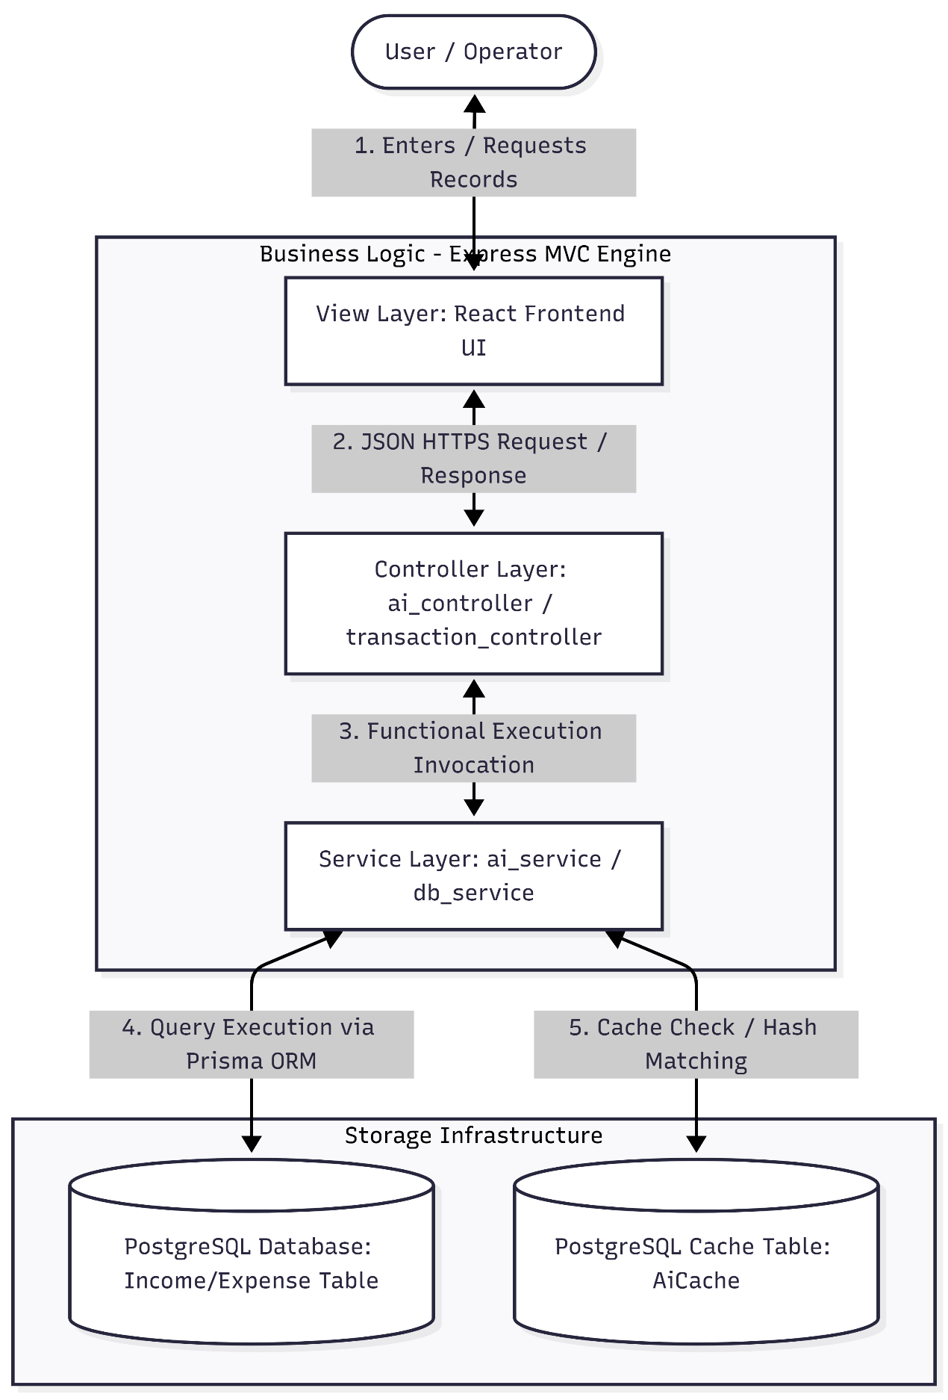
Figure 2.5Program Flow Diagram
For the specific AI request flow, the following diagram shows the additional caching and limit-enforcement steps that occur between the controller and the Gemini API:
2.5 Security Design
The system applies security controls at multiple layers:
Password Security: All passwords are hashed with bcrypt at saltRounds = 12 before storage. Plain-text passwords are never logged, stored, or returned in any API response. The find_by_id_with_password model function is the only query that includes the password field, and it is called exclusively from the change_password service function.
Token Security: Access tokens are stored in React application memory (not localStorage) to prevent XSS-based theft. Refresh tokens are stored as bcrypt hashes in the database, so even database access does not expose the raw token value. The httpOnly cookie flag prevents JavaScript from reading the refresh token.
Ownership Enforcement: Every record query includes WHERE user_id = ? AND deleted_at IS NULL. This double filter ensures users can never read, modify, or delete records belonging to another user, and cannot access their own soft-deleted records through normal endpoints.
Input Sanitization: A global Express middleware strips HTML tags from all string inputs in req.body before any route handler processes them, preventing stored XSS attacks.
Rate Limiting: The login endpoint is limited to 10 requests per IP per 15 minutes using express-rate-limit. The registration endpoint is limited to 5 per IP per hour. These limits prevent brute-force credential attacks.
Chapter 3: RESULT OF COURSE PROJECT
3.1 System Running Results
The following screenshots demonstrate the system running in a local development environment. The frontend is served by the Vite development server on port 5173 and communicates with the Express.js backend on port 5000. All data shown in the screenshots is generated from the database seed file, which populates two user accounts, 13 system categories, and 15 sample financial records covering income and expense transactions across multiple months.
3.1.1 Authentication Pages
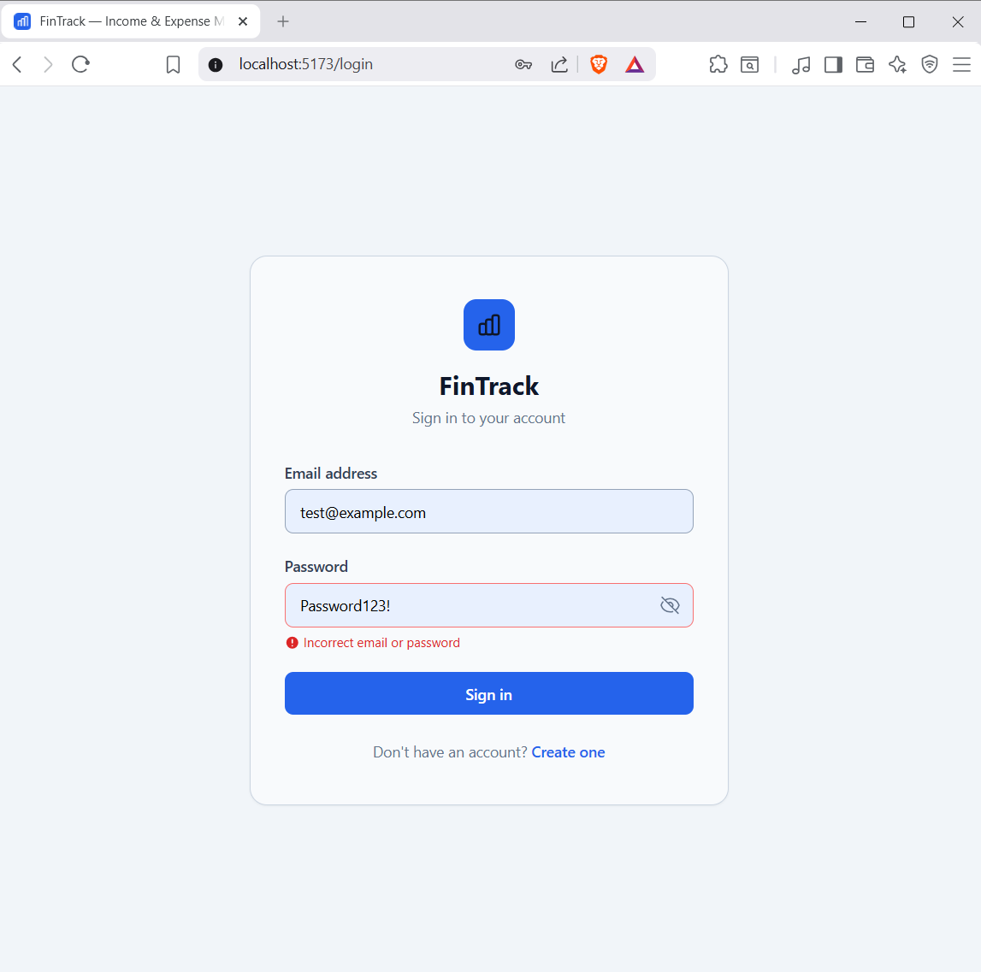
Figure 3.1 — Login Page.
The login form validates email format and password presence on the client side before submission. Incorrect credentials return a field-level error message under the password field rather than a browser alert dialog. A logged-in user who navigates to this URL is automatically redirected to the dashboard.
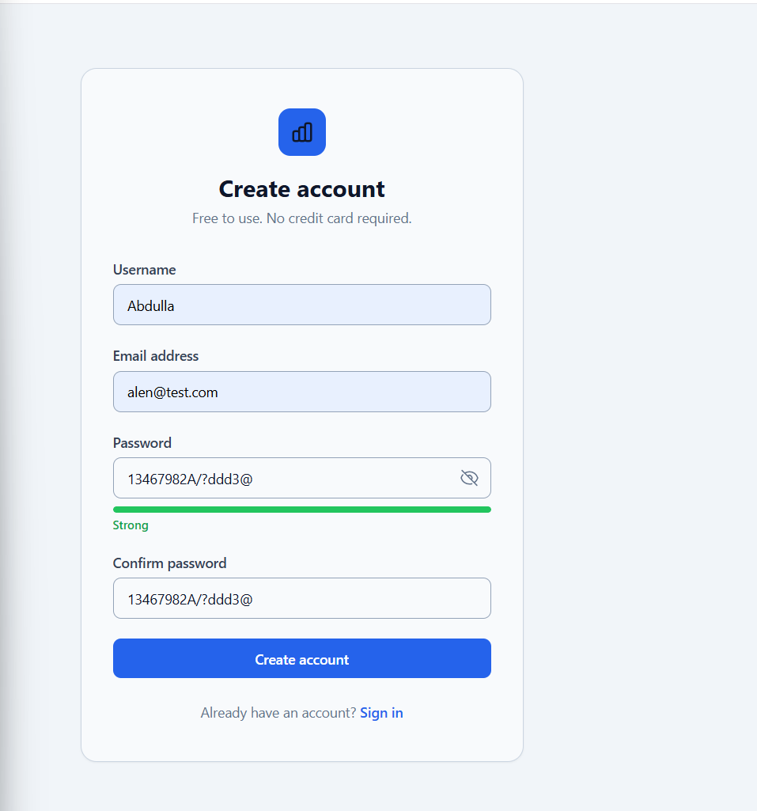
Figure 3.2 — Registration Page.
The registration form includes a real-time password strength indicator that scores the input on length, numeric characters, and special characters without making an API call.

3.1.2 Dashboard
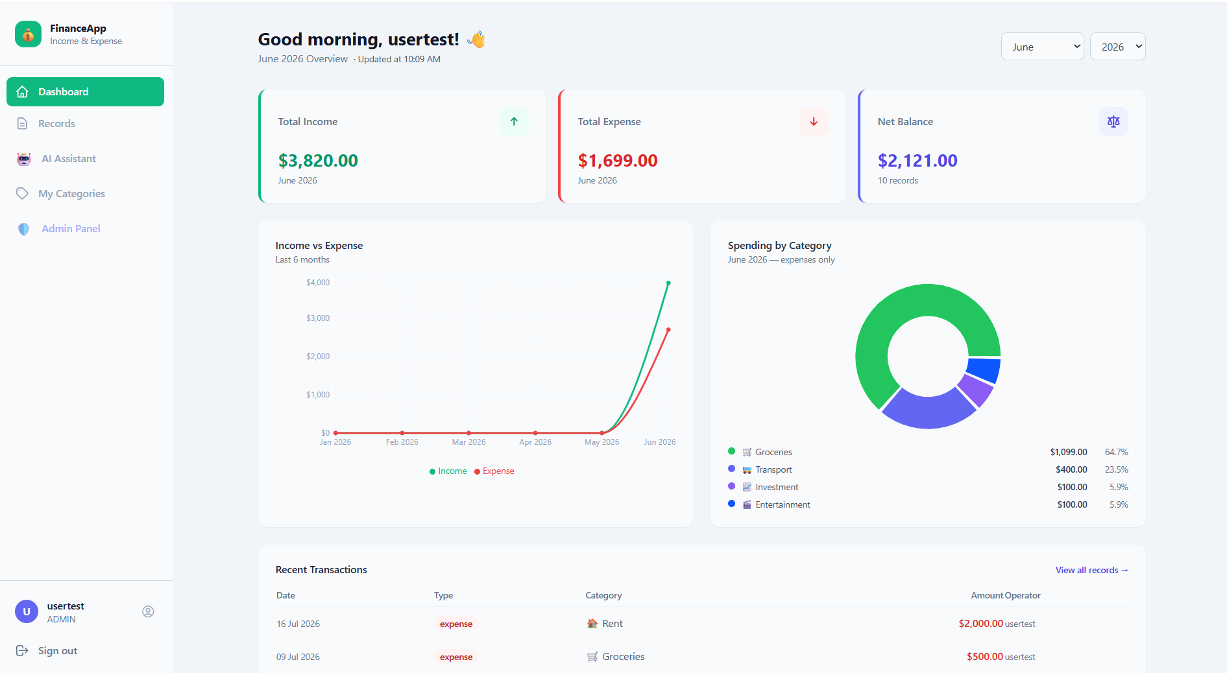
Figure 3.3 — Dashboard Overview.
The dashboard displays three summary cards (total income, total expense, and net balance for the current month), a six-month income-versus-expense line chart, a spending breakdown donut chart colored by category, and a table of the five most recent transactions. All four data sections are fetched in parallel using Promise.allSettled, so a failure in one section does not blank the remaining three.

3.1.3 Records Page — Core CRUD Functionality
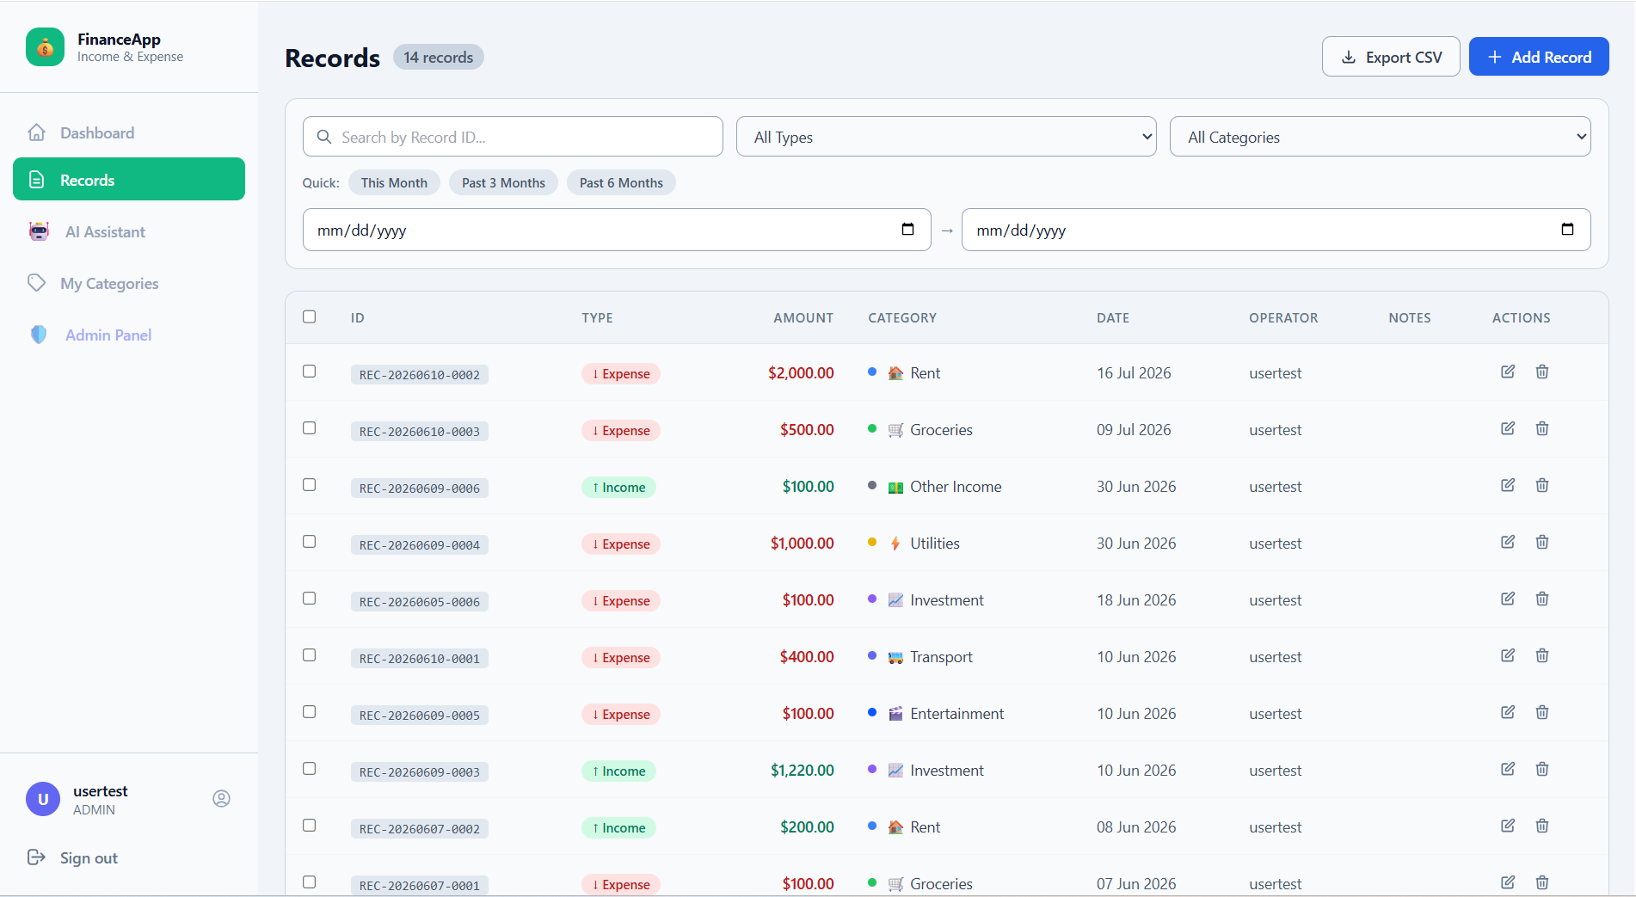Figure 3.4 — Records List View.
The records table displays all active transactions with their Record ID, type badge (income in green, expense in red), formatted amount, category icon and name, date, and operator. Each row contains an Edit button and a Delete button, satisfying the teacher's requirement that both operations are directly accessible from the list view.
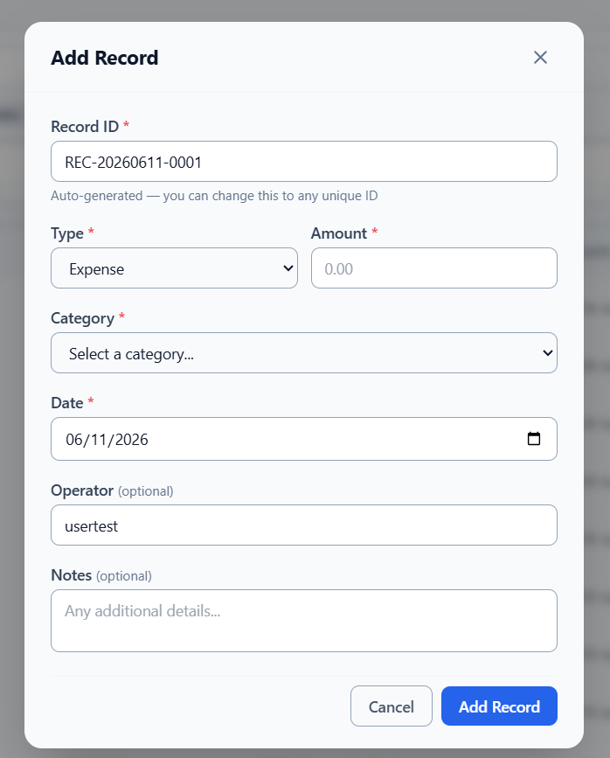
Figure 3.5 — Add Record Form.
The Add Record modal pre-fills the Record ID field with a backend-generated suggestion in the format REC-YYYYMMDD-NNNN. The user may accept this value or type their own. The Amount field uses a text input with decimal keyboard mode rather than a numeric input to prevent browser rounding. All mandatory fields are validated before the API call is made.
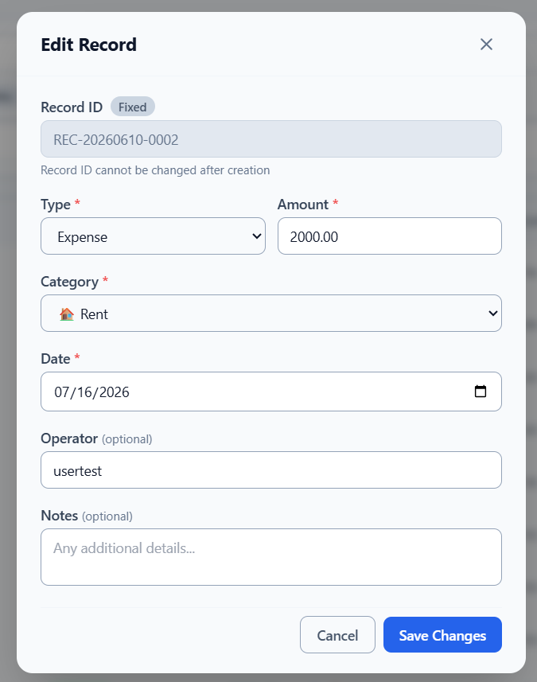
Figure 3.6 — Edit Record Form.
When a record is opened for editing, the Record ID field is rendered with the HTML disabled and readOnly attributes and displays a gray "Fixed" badge beside its label. This visually communicates — and technically enforces — that the Record ID cannot be modified after creation
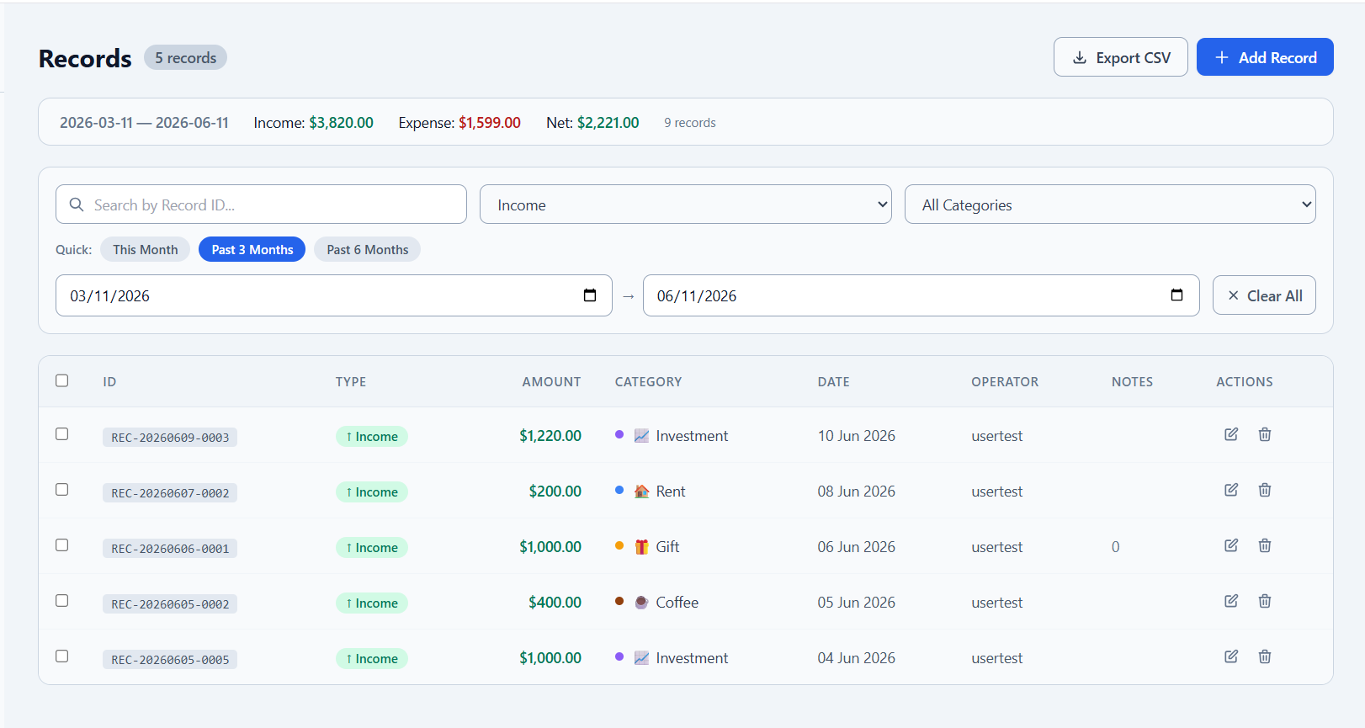
Figure 3.7 — Server-Side Search and Filtering.
The search bar provides filters for Record ID (partial text match), transaction type (income or expense), category, and date range with quick-select preset buttons for the current month, past three months, and past six months. All filtering is performed server-side — the URL reflects the active parameters also in the top shows the summary of income and expenses

3.1.4 Categories Page
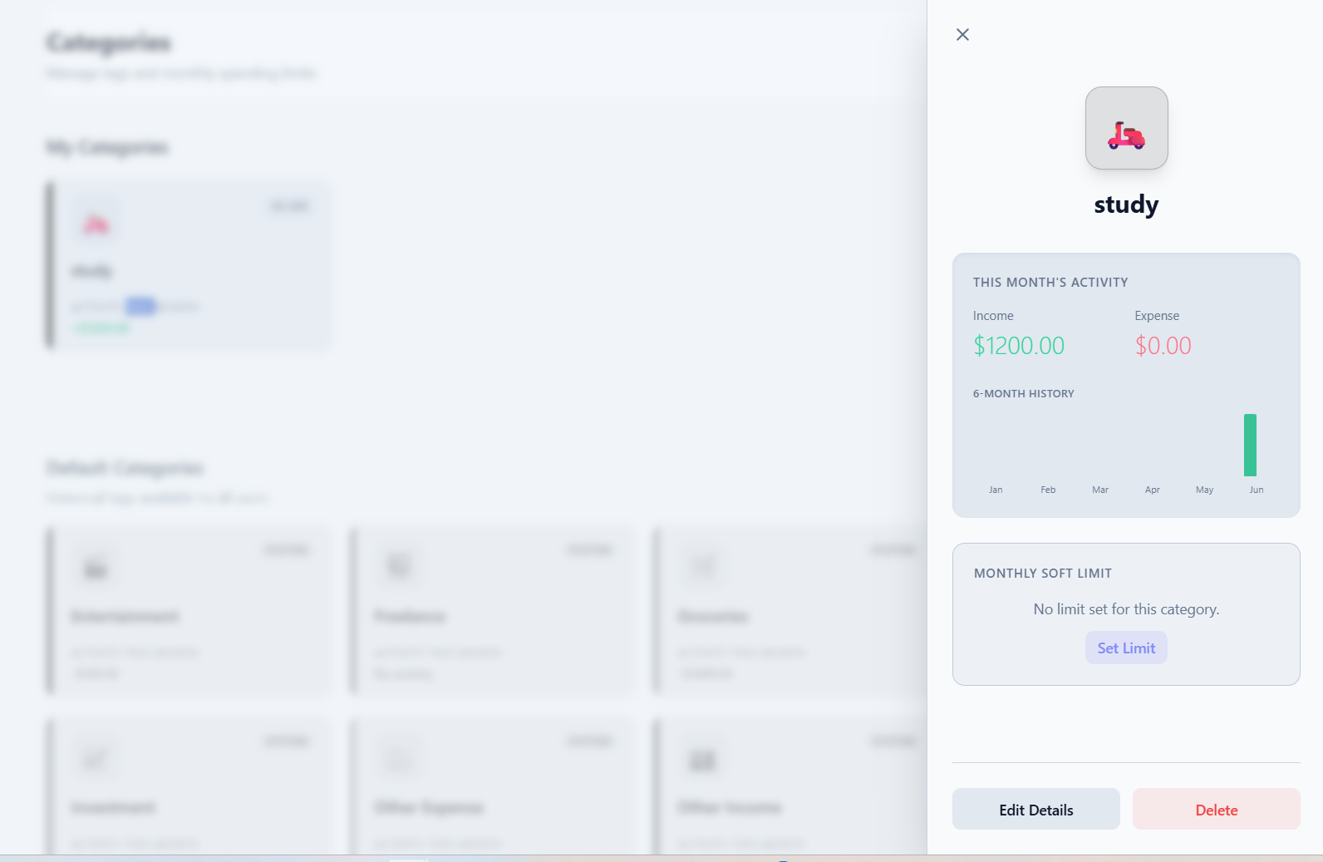
Figure 3.8 — Categories Page.
The categories page displays both system-wide categories and the user's personal categories in a card grid. Cards with a monthly budget goal set display a color-coded progress bar showing actual spending versus the planned limit. Clicking any card opens a slide-out panel with a six-month spending history chart and detailed budget progress for that category.

3.1.5 AI Assistant
Figure 3.9 — AI Assistant Page.
The AI Assistant page presents three tabs: Budget Planner, Purchase Advisor, and Finance Chat. The usage counter in the header shows the user's remaining daily AI requests. The screenshot shows a generated budget plan in the Budget Planner tab — the AI has analyzed the user's past spending across categories and suggested allocations as a percentage of the target budget, with a brief reasoning note for each category. The user may adjust any suggested amount before saving the plan as persistent budget goals.

3.1.6 Admin Panel
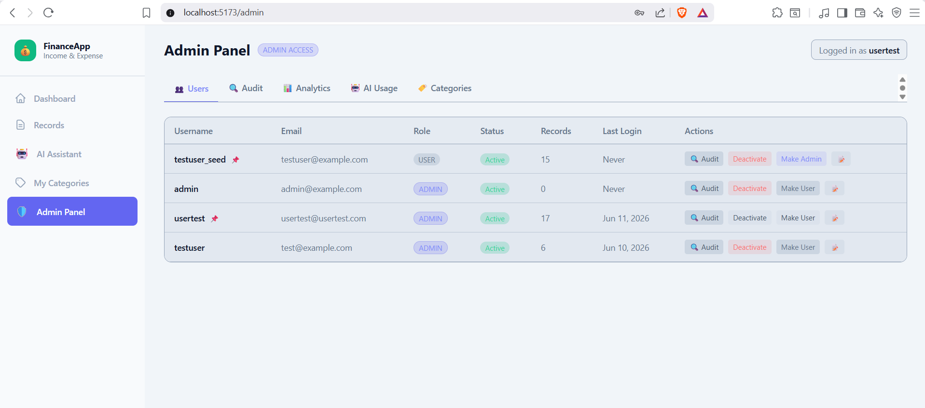
Figure 3.10 — Admin Panel.
The Admin Panel is accessible only to accounts with the ADMIN role. Navigating to the /admin route as a regular user renders an inline 403 Access Denied message rather than a redirect. The screenshot shows the Users tab, which lists all registered accounts with their role badge, active status, and record count. The Promote/Demote and Activate/Deactivate buttons are disabled on the admin's own row, preventing self-modification. Clicking the Audit button on any user row switches to the Audit tab with that user pre-selected.

3.1.7 Profile Page
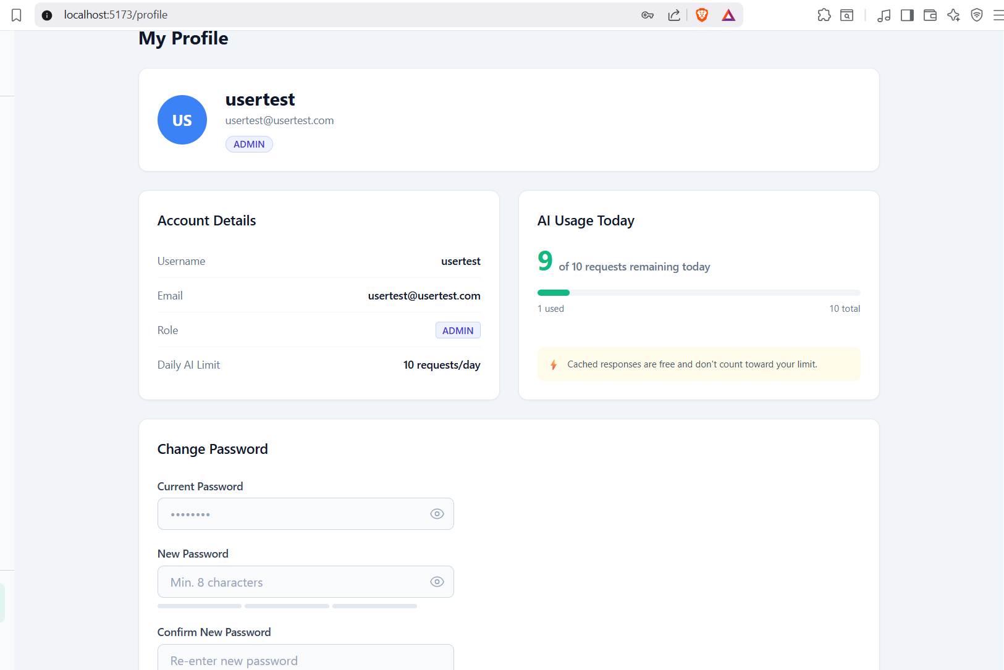Figure 3.11 — User Profile Page.
The profile page displays the user's account information, role badge, and a color-coded AI usage progress bar showing requests consumed versus the daily limit. The password change form requires the current password before accepting a new one, preventing unauthorized changes. A password strength indicator provides real-time feedback as the user types the new password.
3.2 Source Code Overview
The complete project source code is organized into two top-level directories: server/ for the Node.js/Express.js backend and client/ for the React.js frontend.
1. Backend Structure (server/)
The backend is built with Node.js, Express.js, and Prisma ORM.
Directory Breakdown: server/src/
Folder | Description
app.js | The main Express application entry point where middleware and routes are registered.
server.js | Starts the HTTP server and handles port configuration.
controllers/ | Business logic for each feature (Records, AI, Auth, Admin, etc.).
routes/ | API endpoint definitions corresponding to the controllers.
middleware/ | Custom logic for authentication (JWT), admin authorization, and request validation.
services/ | External integrations, primarily for the Gemini AI API logic.
models/ | Helper logic or schemas (Prisma handle models via schema.prisma).
utils/ | Shared helper functions (csv export, date formatting).
scripts/ | Maintenance scripts and manual tasks.
Database Strategy: server/prisma/
- schema.prisma: Defines the data models (Users, Records, AiCache, etc.).
- seed.js: Populates the database with initial categories and roles.

2. Frontend Structure (client/)
The frontend is a modern React.js application built using Vite and styled with Tailwind CSS.
Directory Breakdown: client/src/
Folder | Description
main.jsx | The application entry point (DOM mounting).
App.jsx | Root component managing routing and global providers.
pages/ | Full-page views: Dashboard, Records, AI Assistant, Login, etc.
components/ | Reusable UI elements, organized by feature (e.g., records/RecordTable).
context/ | Global state management (Auth state, User roles).
services/ | API client logic for communicating with the backend.
utils/ | Client-side formatting and data processing helpers.
Styling
- index.css: Global styles and Tailwind directives.
- tailwind.config.js: Design tokens and theme configuration.
Key Source Code Excerpts
The following excerpts demonstrate the architectural principles (MVC separation and AI caching) applied throughout the actual codebase.
Excerpt 1 — Controller Layer (
record_controller.js)
The controller acts as a thin dispatcher, parsing the request and delegating to the service layer.
javascript
async function create(req, res) {
try {
const record = await record_service.create_record(req.user.id, req.body);
return send_success(res, record, 201);
} catch (err) {
const status = err.message === 'Record ID already exists' ? 409 : 400;
return send_error(res, err.message, status);
}
}
Excerpt 2 — Service Layer (
record_service.js)
The service layer handles validation, business rules, and coordinates between models. It is decoupled from the database implementation.
javascript
// ARCHITECTURE GUARD: This file must never import PrismaClient.
// All DB access goes through functions in src/models/record_model.js only.
async function create_record(user_id, data) {
const { type, amount, category_id, date, operator, notes } = data;
let record_id = data.id;
// 1. Mandatory field presence check
if (!type) throw new Error('Type is required');
if (amount === undefined || amount === null || amount === '') throw new Error('Amount is required');
if (!category_id) throw new Error('Category is required');
if (!date) throw new Error('Date is required');
// 2. Amount validation (decimal precision)
validate_amount(amount);
// 3. CRITICAL: check ALL records, including soft-deleted, to protect audit trail
const existing = await record_model.find_by_id_any(record_id);
if (existing) {
throw new Error('Record ID already exists');
}
// 4. Validate category exists and is active
await validate_category(category_id);
return serialize_record(
await record_model.create({
id: record_id,
type, amount, category_id,
date: new Date(date),
operator: String(operator).trim(),
notes: notes ?? null,
user_id,
})
);
}
Excerpt 3 — Model Layer (
record_model.js)
The model layer contains the actual Prisma queries, abstracting the database logic from the rest of the application.
javascript
/*
* FUNCTION : create
* WHY : Inserts a new record. All validation already done in service.
*/
async function create(data) {
const { category_id, user_id, ...scalar_fields } = data;
return prisma.record.create({
data: {
...scalar_fields,
category: { connect: { id: category_id } },
user: { connect: { id: user_id } },
},
include: CATEGORY_JOIN,
});
}
Excerpt 4 — AI Service Cache Pattern (
ai_service.js)
This snippet demonstrates the cache-first pattern used to optimize performance and enforce daily limits for AI features.
javascript
/*
* FUNCTION : run_with_cache
* WHY : Implements the mandatory cache-first pattern for all AI features.
* Cache hits are FREE and bypass daily limit checks.
*/
async function run_with_cache({ cache_key, feature_name, user_id,
daily_limit, ttl_ms, gemini_fn }) {
// Step 1 — Check cache before anything else
const cached = await ai_cache_model.find_by_key(cache_key);
if (cached) {
await Promise.allSettled([
ai_cache_model.increment_hit(cached.id),
ai_usage_model.log_usage(user_id, feature_name, true, null),
]);
return { data: JSON.parse(cached.response_json), is_cache_hit: true };
}
// Step 2 — Enforce daily limit only for non-cached requests
const today_count = await ai_usage_model.count_today_non_cached(user_id);
if (today_count >= daily_limit) {
const reset_at = new Date();
reset_at.setHours(24, 0, 0, 0); // resets at midnight tonight
const err = new Error('Daily AI limit reached');
err.status = 429;
err.reset_at = reset_at.toISOString();
throw err;
}
// Step 3 — Call Gemini and persist response in cache
const { data, tokens_used } = await gemini_fn();
const expires_at = new Date(Date.now() + ttl_ms);
await ai_cache_model.create_entry(
cache_key, feature_name, JSON.stringify(data), user_id, expires_at
);
await ai_usage_model.log_usage(user_id, feature_name, false, tokens_used);
return { data, is_cache_hit: false };
}
Excerpt 5 — Pagination Utility (
pagination.js)
The pagination utility centralizes the logic for calculating database offsets and formatting standardized response objects.
javascript
/*
* FUNCTION : get_pagination_params
* WHY : Calculates Prisma skip/take based on page/limit query params.
*/
function get_pagination_params(query, default_limit = 10, max_limit = 100) {
const page = Math.max(1, parseInt(query.page) || 1);
const limit = Math.min(
max_limit,
Math.max(1, parseInt(query.limit) || default_limit)
);
const skip = (page - 1) * limit;
return { skip, take: limit, page, limit };
}
/*
* FUNCTION : format_paginated_response
* WHY : Standardizes the shape of all paginated list responses.
*/
function format_paginated_response(data, total, page, limit) {
return {
data,
pagination: {
total,
page,
limit,
total_pages: Math.ceil(total / limit),
},
};
}

